INTRODUCTION TO SELENIUM WEB DRIVER

SELENIUM WEB DRIVER INSTALLTION

1. Install java
2. Download eclipse http://www.eclipse.org/downloads/eclipse-packages/
3. Download selenium web driver <http://www.seleniumhq.org/download/>
4. Gecko driver if selenium version >2 (If you are using selenium version 2 you don’t require gecko driver you can launch web driver directly. But if you are selenium 3 version which is the latest version you have to use gecko driver). Download it and extract

<https://github.com/mozilla/geckodriver/releases>

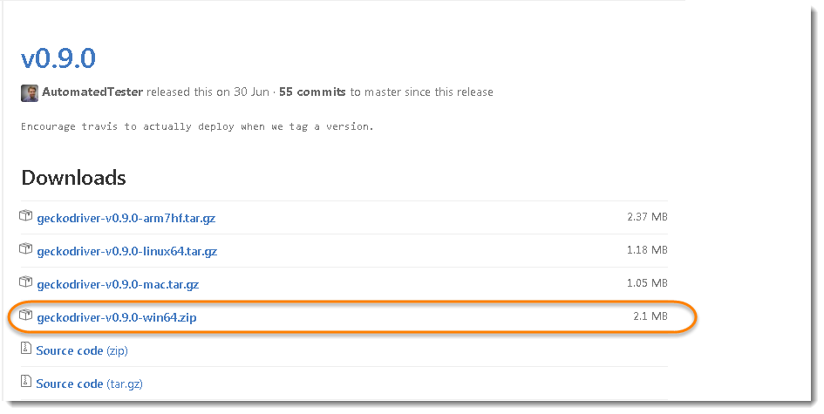

1. Configure eclipse with selenium web driver

**How to configure eclipse with web driver**

1. Open eclipse , create a new project : File -> New -> Java project -> give project name (Ex:project1) -> finish
2. Right click on the project created, buid path -> configure build path ->libraries -> add external jars -> select all .jars files in selenium web driver folder ->ok ( unzip the downloaded selenium web driver into a folder)

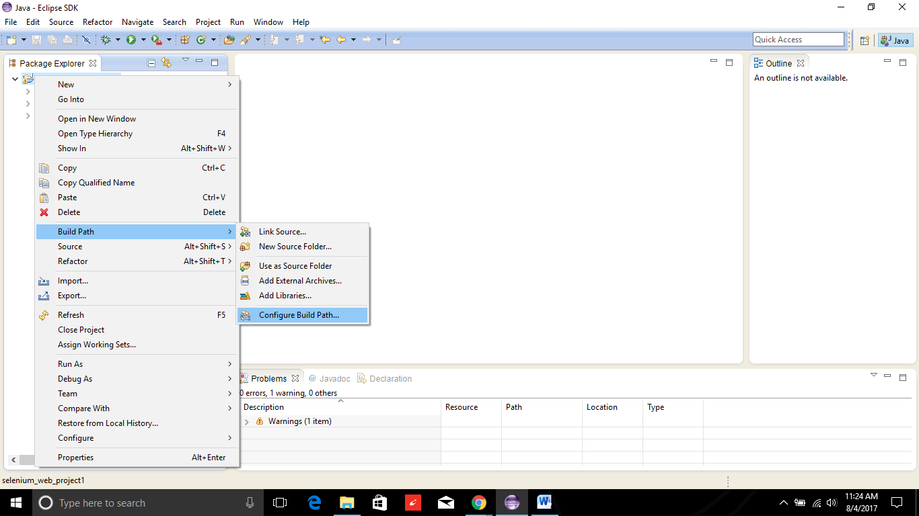

Add all the .jars

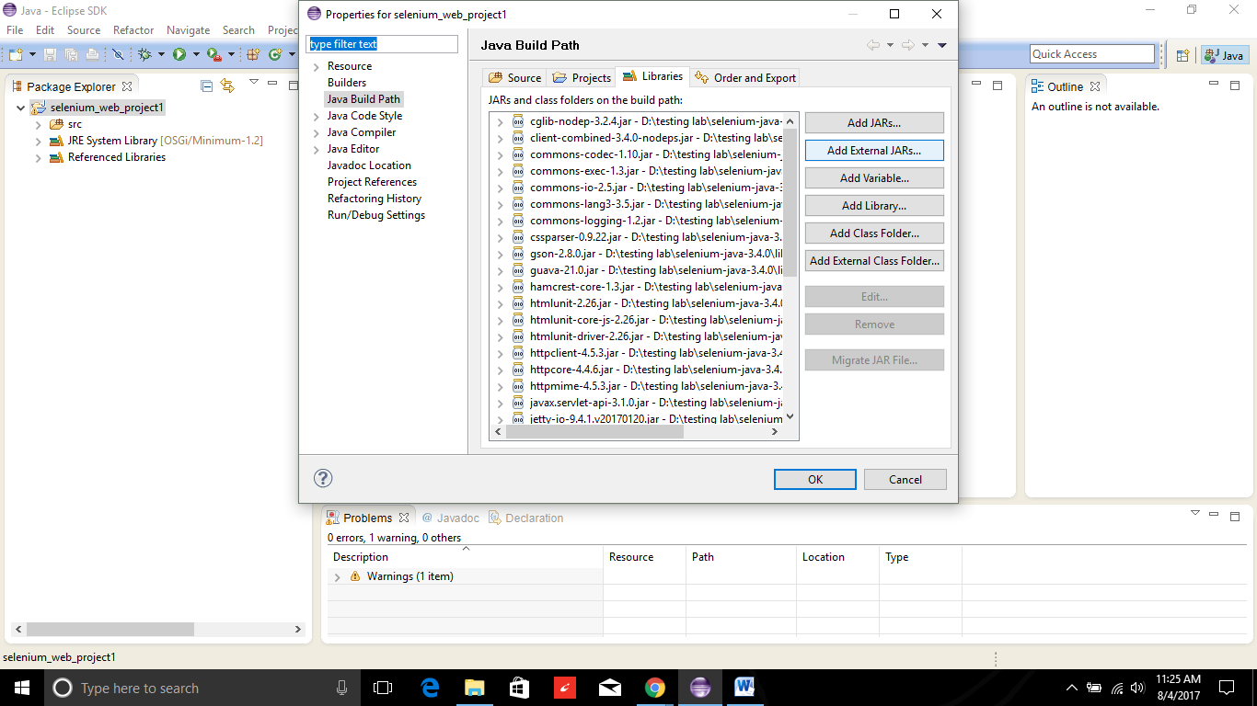

Your project is configured with selenium web driver now.

**SELENIUM WEB DRIVER AND FIREFOX DRIVER**

**Simple program to open a web page**

**import** org.openqa.selenium.WebDriver;

**import** org.openqa.selenium.firefox.FirefoxDriver;

**public** **class** sample1 {

**public** **static** **void** main(String[] args) {

WebDriver driver =**new** FirefoxDriver();

driver.get("https:\\www.google.com");

}

}

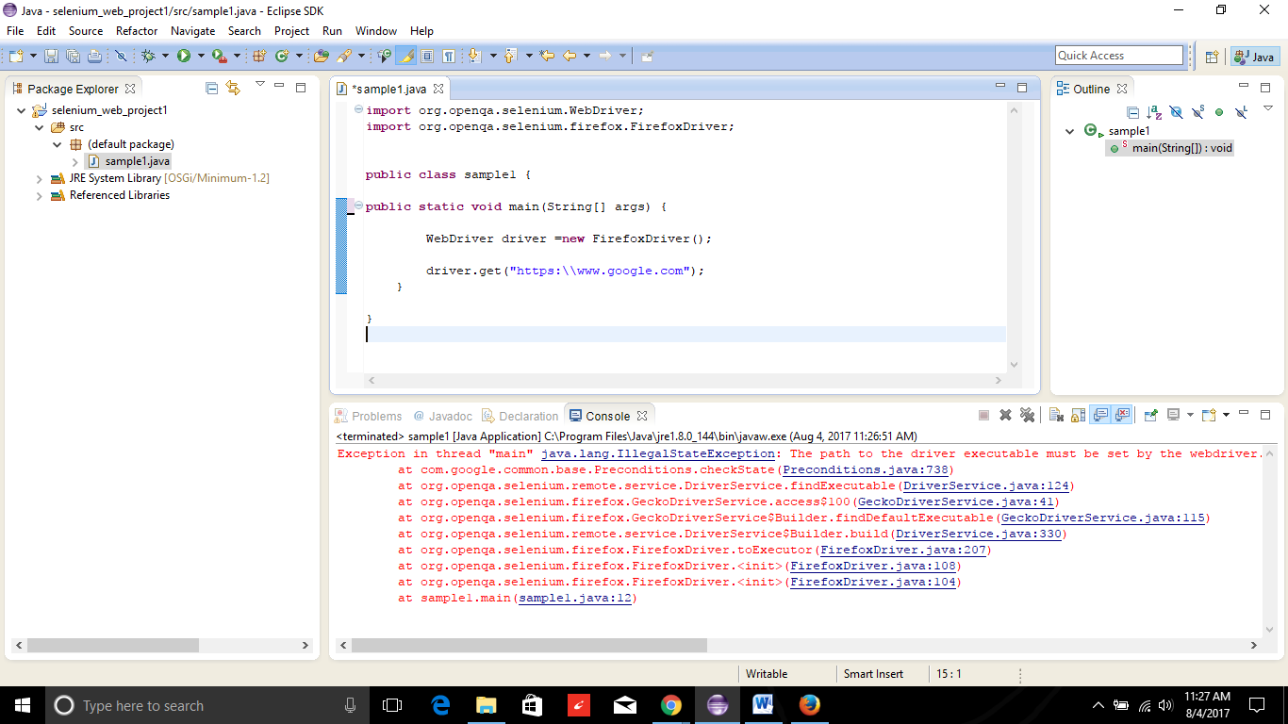

**It’s giving an error java.lang.illegalstateexception : The reason is we are using selenium3.4.0 version .If it is seelnium2 version web driver will launch directly as it’s selelnium 3 version we have use gecko driver.**

**import** org.openqa.selenium.WebDriver;

**import** org.openqa.selenium.firefox.FirefoxDriver;

**public** **class** sample1 {

**public** **static** **void** main(String[] args) {

System.*setProperty*("webdriver.gecko.driver","D:\\\\testing lab\\geckodriver.exe");

WebDriver driver =**new** FirefoxDriver();

driver.get("https:\\www.google.com");

}

}

System.*setProperty*("webdriver.gecko.driver","D:\\\\testing lab\\geckodriver.exe");

**Two ways to use gecko driver:**

1. **Use in every program using the syntax** System.*setProperty*("webdriver.gecko.driver"," file path where gecko driver.exe is saved");
2. **Set in environment variables**

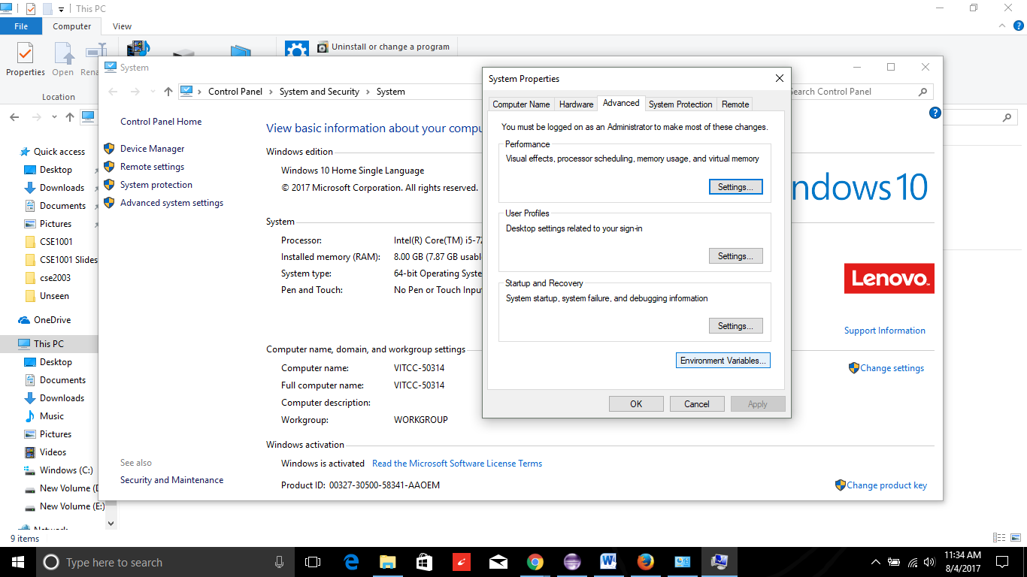

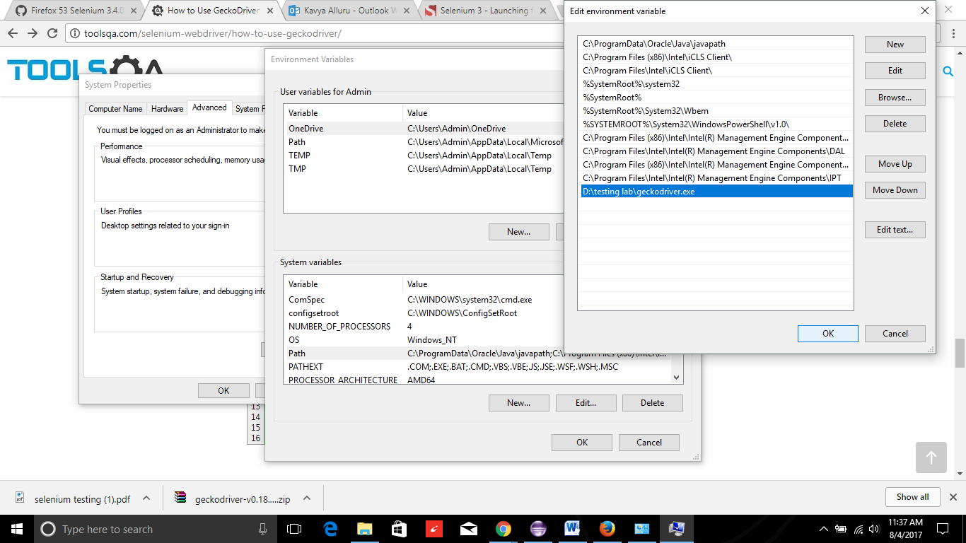

**LOCATING WEB ELEMENTS**

|  |  |  |
| --- | --- | --- |
| **Variation** | **Description** |  |
| By.**className** | finds elements based on the value of the "class" attribute | findElement(By.className("someClassName")) |
| By.**cssSelector** | finds elements based on the driver's underlying CSS Selector engine | findElement(By.cssSelector("input#email")) |
| By.**id** | locates elements by the value of their "id" attribute | findElement(By.id("someId")) |
| By.**linkText** | finds a link element by the exact text it displays | findElement(By.linkText("REGISTRATION")) |
| By.**name** | locates elements by the value of the "name" attribute | findElement(By.name("someName")) |
| By.**partialLinkText** | locates elements that contain the given link text | findElement(By.partialLinkText("REG")) |
| By.**tagName** | locates elements by their tag name | findElement(By.tagName("div")) |
| By.**xpath** | locates elements via XPath | findElement(By.xpath("//html/body/div/table/tbody/tr/td[2]/table/tbody/tr[4]/td/table/tbody/tr/td[2]/table/tbody/tr[2]/td[3]/ form/table/tbody/tr[5]")) |

**WEB DRIVER PROGRAM USING FIREFOX (GMAIL VERIFICATION)**

**import** org.openqa.selenium.By;

**import** org.openqa.selenium.WebDriver;

**import** org.openqa.selenium.firefox.FirefoxDriver;

**public** **class** sample1 {

**public** **static** **void** main(String[] args) {

System.*setProperty*("webdriver.gecko.driver","D:\\\\testing lab\\geckodriver.exe");

WebDriver driver =**new** FirefoxDriver();

driver.get("https://accounts.google.com/signin/v2/identifier?continue=https%3A%2F%2Fmail.google.com%2Fmail%2F&service=mail&sacu=1&rip=1&flowName=GlifWebSignIn&flowEntry=ServiceLogin");

driver.findElement(By.*id*("identifierId")).sendKeys("alluru.kavya");

driver.findElement(By.*xpath*(".//*[@id='identifierNext']/content/span")).click();

driver.findElement(By.*xpath*(".//*[@id='password']/div[1]/div/div[1]/input")).sendKeys("abbca");

}

}

**WORKING WITH MULTIPLE BROWSERS**

**import** org.openqa.selenium.WebDriver;

**import** org.openqa.selenium.firefox.FirefoxDriver;

**public** **class** SAMPLE2 {

/**

* **@param** args

*/

**public** **static** **void** main(String[] args) {

System.*setProperty*("webdriver.gecko.driver","D:\\\\testing lab\\geckodriver.exe");

WebDriver driver =**new** FirefoxDriver();

WebDriver driver1 =**new** FirefoxDriver();

driver.get("https:\\www.gmail.com");

driver1.get("https:\\www.yahoo.com");

**Get Commands**

Get commands fetch various important information about the page/element. Here are some important "get" commands

|  |  |
| --- | --- |
| **get()** *Sample usage:* | * It automatically opens a new browser window and fetches the page that you specify inside its parentheses. * It is the counterpart of Selenium IDE's "open" command. * The parameter must be a **String** object. |
| **getTitle()** *Sample usage:* | * Needs no parameters * Fetches the title of the current page * Leading and trailing white spaces are trimmed * Returns a null string if the page has no title |
| **getPageSource()** *Sample usage:* | * Needs no parameters * Returns the **source code of the page** as a String value |
| **getCurrentUrl()** *Sample usage:* | * Needs no parameters * Fetches the string representing the **current URL** that the browser is looking at |
| **getText()** *Sample usage:* | * Fetches the **inner text** of the element that you specify |

**Navigate commands**

These commands allow you to  refresh,go-into and switch back and forth between different web pages.

|  |  |
| --- | --- |
| **navigate().to()** *Sample usage:* | * It automatically **opens a new browser window and fetches the page** that you specify inside its parentheses. * **It does exactly the same thing as the get() method.** |
| **navigate().refresh()***Sample usage:* | * Needs no parameters. * It **refreshes** the current page. |
| **navigate().back()***Sample usage:* | * Needs no parameters * Takes you **back by one page** on the browser's history. |
| **navigate().forward()***Sample usage:* | * Needs no parameters * Takes you **forward by one page** on the browser's history. |

**Closing and Quitting Browser Windows**

|  |  |
| --- | --- |
| **close()** *Sample usage:* | * Needs no parameters * **It closes only the browser window that WebDriver is currently controlling**. |
| **quit()** *Sample usage:* | * Needs no parameters * **It closes all windows that WebDriver has opened.** |